**Zooming in on graduate attributes**



* Application of knowledge
* Willingness to learn
* Problem solving
* Research skills
* Reflective practice
* Knowledge of plagiarism and copyright

Here are some examples of the five graduate attributes in practice. These have been drawn from students and staff who have shared their experiences with us.

Designed to support reflection, dialogue and personal development aspirations and planning, you are encouraged to work with the graduate attributes in ways that are meaningful to you.

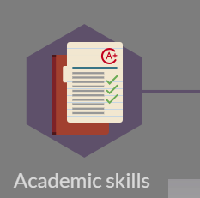

Employability and career management skills

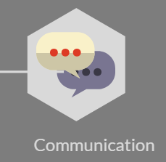

* Digital literacy
* Written communication
* Verbal communication
* Listening
* Presenting
* Public speaking



* Planning study time
* Developing resilience
* Taking initiative
* Efficient and effective
* Positive attitude
* Developing confidence

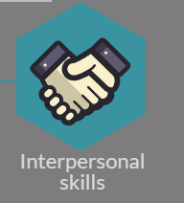

* Contributing to group projects
* Emotional intelligence
* Honesty and reliability
* Works with difference and diversity
* Gives and receives feedback effectively



* Volunteering
* Work placement
* Ethical behaviour
* Community engagement
* Global awareness
* Equality and diversity

Please tell us about your own examples of ways you have worked with the graduate attributes by [sharing them with us](mailto:lta@uhi.ac.uk).