STUDENT SUPPORT INITIATIVE AWARD 2017
NOMINATED PROJECT - INVERNESS COLLEGE UHI BUSINESS COMPETITION, LED BY CREATE (CENTRE FOR ENTERPRISE AND INNOVATION).
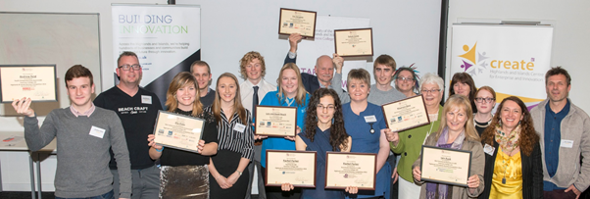

1) Outline the project or initiative and what makes it innovative and inspiring (max 300 words).
What does UHI want to inspire in its students? As educators we want our learners to leave their studies at UHI as confident individuals who have a ‘can-do will-do, be all you can be’ attitude that prepares them for the world of work and/or self-employment, if they so choose.
The Inverness College UHI, Business Competition inspires, encourages and supports students from across all UHI colleges and research centres to act in a way that will lead them towards becoming an enterprising and entrepreneurial graduate and put them in a stronger position amongst their peers with regards to becoming employed, but more importantly, helping them develop those transferable skills that will allow them to remain employable.
The competition not only ‘adds value’ to an already full and varied curriculum, it also promotes the development of enterprising and entrepreneurial behaviours and skills such as opportunity spotting, taking the initiative, creative problem solving, presenting ideas and building relationships. It enables all UHI students who enter to practice these skills in a safe and supportive environment where CREATE staff work to ensure they feel supported at all stages of the competition. Our support involves training to develop their ideas, help with constricting an application, advice and practice on presenting to judges, 1-2-1 support (post competition) and introductions to other organisations that can also help them.
Each year we actively encourage entries from FE, HE and postgraduate students as well as researchers. To date the competition has encouraged 700+ students from across all curriculum areas, to enter and annually award £8k in prize money. Part of the competition’s uniqueness lies in the extensive network of staff and student champions that we have built to encourage students to enter. This collaboration ensures open and ease of access to the competition across UHI and encourages maximum impact. (word count -300)

2) Detail how the project or initiative was delivered, from the planning stage through to its successful conclusion. Include details of timing and funding (max 300 words).
Date | Activity
Mar – Jul 16  Securing Funding and Planning | Competition is not core funded and each year CREATE work tirelessly to attract sufficient external funding to support its running and prize pot.  3 independent judges are recruited yearly with the knowledge and experience of the realities of establishing/running small businesses (commercial and social) and are able to appreciate and provide constructive feedback on the range of diverse business ideas that can come from our tertiary student based competition.  Marketing messages, material and online application form are developed.
Sept - Nov 16  Launch, Promotion and Support | Competition launched with extensive promotional coverage including H&I/UHI partners/Subject Network/VLE wide poster distribution, social media ad press releases.  During this time CREATE ran student workshops on idea generation, drop in sessions and student class briefings to raise student awareness and encourage entries. We engaged with 46 different student groups and 1000+ students.
Closing Date for Entries 3rd Nov | Judges met at IC 10th Nov to discuss entries and champion those that they felt should be shortlisted. A shortlist of 15 was finally agreed from 132 entrants.
10th - 23rd November | All those not shortlisted were written to and offered 1-2-1 support as well as signposting to other agencies or competitions that would help them move their idea or business forward.  All shortlisted entrants were offered bespoke mentoring on their presentation/pitch, prior to meeting the judges on 24th November.
24th November | A full on day - Throughout the day (8am – 9pm) 15 Finalists presented to the judges who agreed on prize allocations. The evening Awards Ceremony, held at IC began with a buffet dinner for finalists and their guests as well as invitees from the local business community. Guest speakers were Anna Renouf, 2015 student winner as well as local entrepreneur Sam Faircliff, MD Cairngorm Brewery.
(word count 300)

3) Outline the project or initiatives outcome(s) within the university and beyond with relevant supporting evidence, metrics or testimony where appropriate (max 400 words).
Evidence of impact
£55k sponsorship was secured from 40+ businesses by CREATE and awarded each year as prizes. 1100+ entries have been received since 2006, including 700+ student entries from the UHI partnership (others from the H&I community).
In 2016, we worked with 46 UHI-wide student groups (engaging face-to-face with 1000+ students) to support building their enterprising attitudes, skills and ideas.
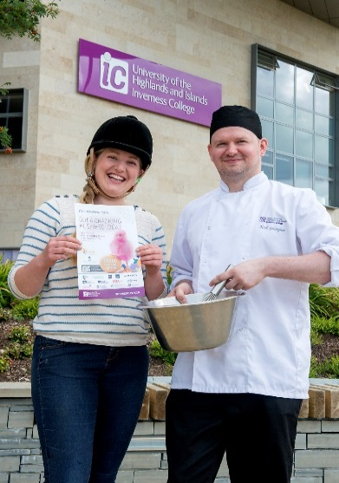
Of the 132 entries in 2016, 10 UHI colleges and research centres were included, with 28-curriculum areas represented (highest range of disciplines so far).
Two Examples of Learner Progression
Nick Gallagher, ICUHI HNC Hospitality student won ‘Best Researched Idea’ in 2014. Nick established Black Tartan Food, and was awarded 2016 Bridge2Business Entrepreneurial Student of the Year.
Anna Renouf, BSc (Hons) in Environmental Science student, after winning 2 prizes in 2015, was supported to enter SIE and Converge Challenge awards, wining ‘Best Entrepreneurial Spirit’ and continues to pursue her innovative idea.
Testimonials
Melanie MacArthur (previous HND beauty student at ICUHI) won Best Commercial Business 2013, established Vogue Beauty in Nairn said, “I wouldn’t have started my business if I hadn’t entered the competition”.
Rachel Parker, SAMS student, won 2016 Top prize and Best Student Business, “has been a great experience as it will help me take my business idea to the next stage”.
Calum Smith an ICUHI Engineering student won Most Innovative Business in 2016, “I was really shocked when I found out I had won the prize for most innovative business – it’s really exciting and I’m looking forward to developing my idea further”.
Extracts feedback on support to enter compt | “It was very helpful to have the clarity of what the judging panel would be looking for. This wasn’t generic advice, it was tailored to my specific business idea and pitch”  “It was very useful. It’s not something I have done very much of before, so sitting down and planning a structure to my presentation was key”
Feedback on the 1-2-1 follow-up support we offer to all student entrants | “What I took from the [..] session was that I am actually capable of setting up in business and that I have the confidence to go ahead in taking steps to move my idea forward”  “It’s been such an encouragement and boost to my confidence. I think the most valuable part of these sessions has been my mentor’s ability to tailor their understanding to and support specifically to my needs”.

[Words – 400]

