University of the Highlands and Islands
Postgraduate Taught Experience Survey 2023

Full report and comments analysis

Table of Contents

1. Introduction 2
2. Executive summary 2
3. Summary of results by area and benchmarking 3
4 Table of responses by question category 8
5 Results by programme 9
6 Analysis of free text comments 10
6.2 Quality of learning and teaching comments 10
6.3 Engagement comments 10
6.5 Organisation comments 11
6.6 Support comments 12
6.7 Skills development comments 12
6.8 Students were asked what was the one most positive aspect of their course. 12
6.9 Students were asked what one thing that would most improve the course experience. 13
7 Conclusions and possible areas for development 15

- Introduction

  - The Postgraduate Taught Experience Survey (PTES) is a national survey, co-ordinated by Advance HE, and run by Student Experience team using ‘Online Surveys’ software.
  - The survey ran from 18/04/23 and closed on 02/06/23.
  - It is the opportunity for taught postgraduates to feedback their experiences on teaching and learning, and the most significant survey of taught postgraduates in the UK.
  - The survey is confidential, and results are anonymised so that no individual can be identified.

- Executive summary

  - The overall satisfaction rate for the university was 92%. This is lower than last year when our rate was 95%, but still higher than 2021 (87%).
  - UHI achieved the highest overall satisfaction rate of any Scottish institution for the second consecutive year.
  - UHI was ranked 3rd in the UK for overall satisfaction. In 2021 we were ranked 4th.
  - The University also achieved the highest satisfaction rate in Scotland in three of the nine areas of student experience.
  - The University had only one area of poor performance, which was student community, where we had the lowest score of Scottish institutions (51%).
  - We also ranked highly for Assessment (6th in UK) and Teaching (8th in UK).
  - UHI is ranked 2nd in the UK for Assessment, and 6th in the UK for Engagement.
  - The university achieved a healthy response rate of 28%, down from 33% last year.
  - The Scottish response rate was 15% and the sector / UK response rate was 21%.
  - In three question sets were UHI was ranked in the top 25% - Assessment, Teaching and Organisation. In a further two we were ranked in the next 25% - Engagement and Support.
  - In two question sets we were in the bottom 25% - Resources and Community.
  - The low ranking for ‘resources’ is likely due to a large proportion of students choosing ‘not applicable’ for on campus library and I.T. facilities, presumably because they study online.
- Summary of results by area and benchmarking

  - The University received the highest overall satisfaction level of all Scottish institutions participating, and additionally the highest satisfaction ranking in three areas of experience measured by the survey.
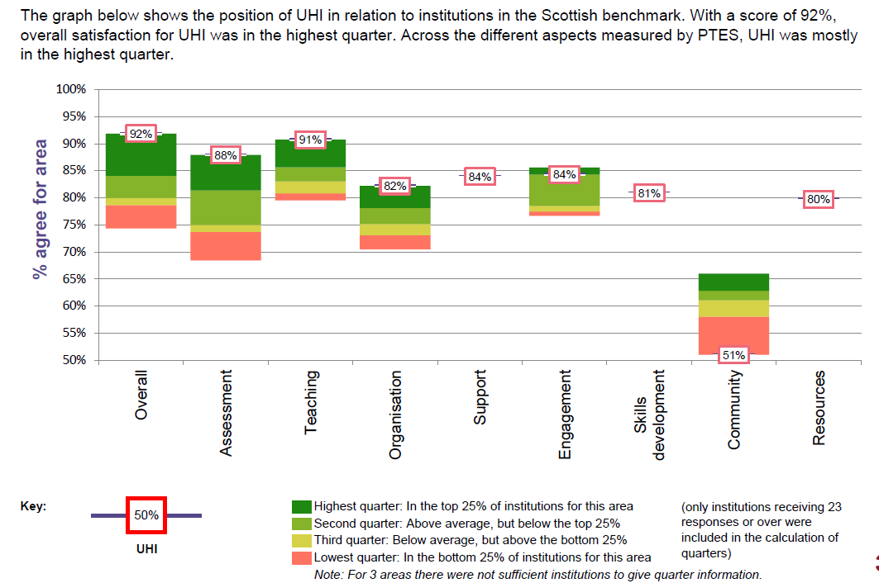
  - The University received a very positive overall satisfaction rate and in several question categories among Post-92 institutions throughout the UK.
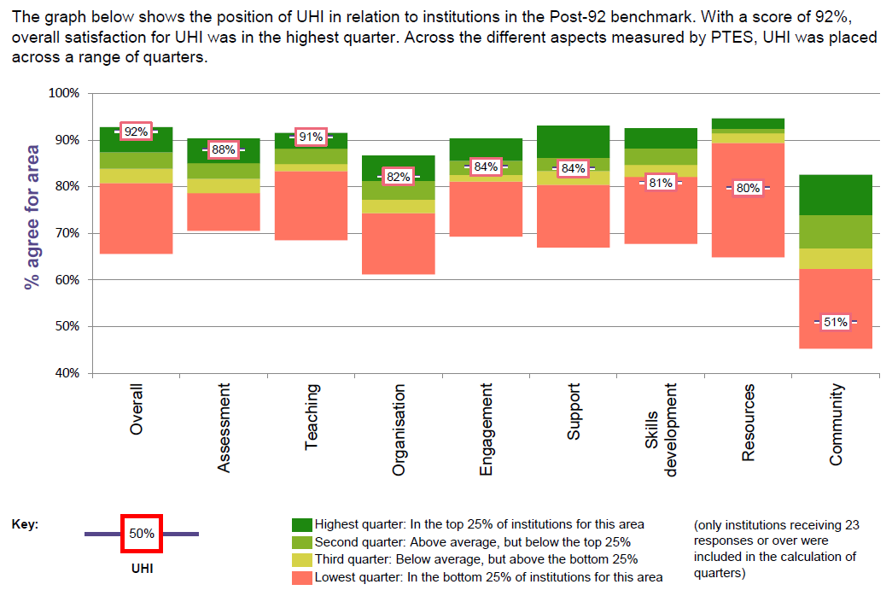
  - Within the sector / UK, UHI was close to the highest level of overall satisfaction and ranked in the top quarter for many areas of experience.
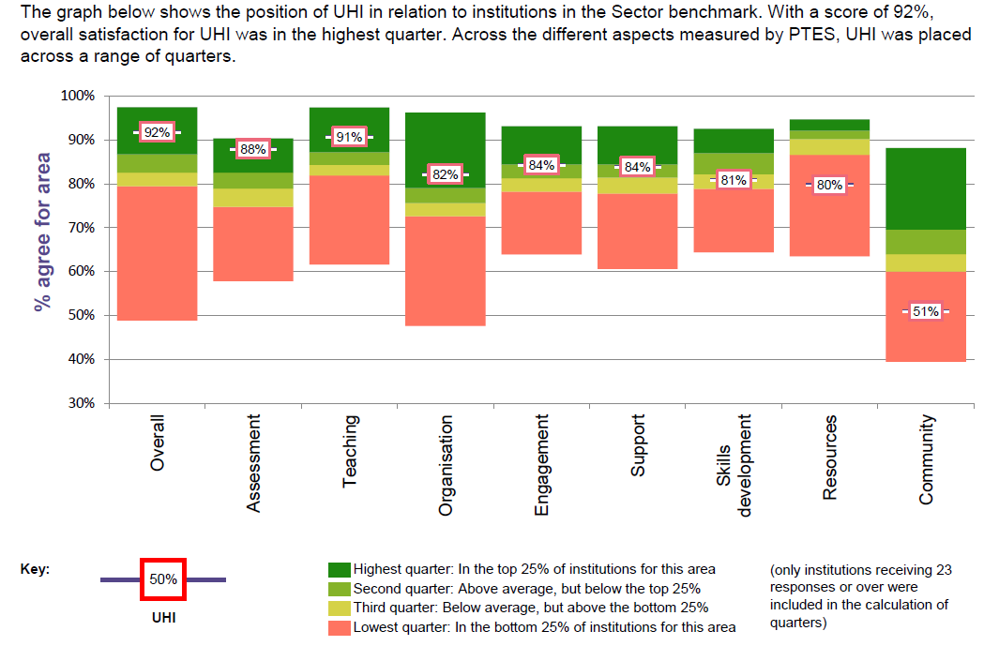
  - An overall comparison with the sector shows UHI 16 percentage points above the Scottish mean for overall satisfaction, and 13 percentage points above the sector (UK) mean for overall satisfaction *.
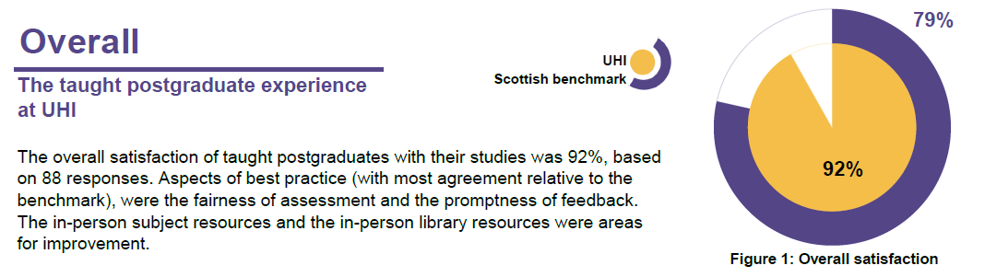

  - The university is in third place overall in the UK sector out of 101 institutions that took part.
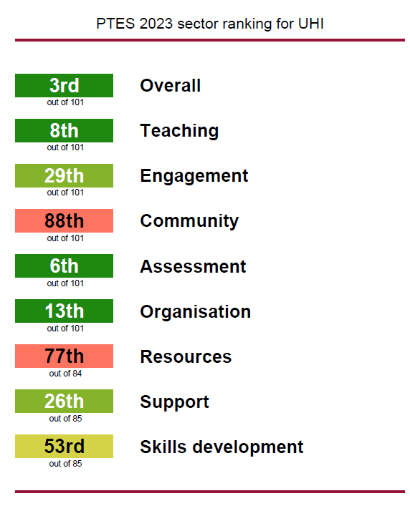

- Table of responses by question category

  - All but one question set have a better score than our results in 2022.
  - Detailed results for all questions are available on Sharepoint.
Question categories | UHI 2023 | UHI 2022 | Sector / UK average 2023 | Scottish sector average 2023
Overall Satisfaction | 92% | 95% | 83% | 79%
Teaching | 91% | 87% | 85% | 81%
Engagement | 84% | 85% | 82% | 79%
Community (new for 2023) | 51% |  | 67% | 59%
Assessment | 88% | 88% | 79% | 73%
Organisation | 82% | 81% | 77% | 73%
Resources | 80% | 79% | 90% | 89%
Support | 84% | 83% | 82% | 78%
Skills Development | 81% | 79% | 83% | 79%

- Results by programme

  - Results, where available, are provided by programme below. Advance HE requires a minimum of five responses to allow reporting.
  - Detailed results by programme are available on SharePoint.
  - Due to the relatively small class sizes at UHI, only a limited number of programme-level results are eligible for reporting.
 | Overall Satisfaction Rate 2023 | Overall Satisfaction Rate 2022
University average | 92% | 95%
Archaeological Studies MLitt | 86% | 94%
Art and Social Practice MA | n/a | 100%
Aquaculture, Environment and Society MSc | 67% | n/a
Contemporary Art and Archaeology MA | 100% | 100%
Health and Wellbeing MA | 85% | 100%
Human Resource Management MSc | n/a | 100%
Sustainable Rural Development MSc | n/a | 94%
Tertiary and Higher Education MEd | 100% | n/a
Viking Studies MLitt | 100% | n/a

Analysis of free text comments

  - Free text comments have been analysed on a university – wide level to identify themes and common issues.
    - The analysis below is provided to inform enhancement.
    - Quotations from students are provided as received and are not changed or corrected in any way.

Quality of learning and teaching comments
    - A number of students mentioned that they would value occasional ‘live’ VC sessions with their class and lecturer :
- “an asynchronous course is a new concept to me so the lack of regular contact was odd.”
- “I could had been more efficient if I had some more classes or meetings with teachers. But maybe it is just not my right way of studying and works for other students.”
- “I would have enjoyed periodic drop in live sessions with a tutor to help keep me on track and to make it easier to get clarification on the assessments but that is just personal preference.”
    - Many students remarked on the speed of staff correspondence with mixed feelings on whether these were fast enough:
- “Tutors are available via webinars and if you have specific queries they can be contacted via email and are usually quite quick to respond.”
- “It was at times, challenging to get a response from lecturers on something with a short deadline as they may have been teaching other courses.”

Engagement comments
    - Within engagement most frequent comments related to workload and time to fully engage with course materials:
- “A lot of work when you work full-time also.”
- “Workload not manageable, but that's not related to the course, but life outside of it.”
- “I felt that the timing between submissions for the 3rd module in the PG Cert were too tight - despite knowing about them, it was difficult to complete anything”
- “The courses were so full of content, and I was working full-time, that there was not the time to fully explore/research the subjects at a deeper level.”

  - Assessment and feedback comments
    - Comments on the helpfulness of assessment were generally positive:
- “I thought feedback was good and it was nice to get audio feedback aswell. It was more personal.”
- “The feedback in my opinion is vital to be able to improve for next time. I have always appreciated the feedback, the positives are great for a confidence boost but the negatives are the best to learn from”
    - Students mentioned the helpfulness of marking schedules:
- “PAT provides timescale of when to expect marks which is very useful whilst others don't and you are left wondering when your assignments will be marked”
- “I don't feel I particularly understood the marking schedule but then I'm not sure if I was allowed to send a draft of my essay to the tutor for feedback prior to final submission or not - I sent my essays to fellow students but this wasn't really helpful for feedback.”

Organisation comments
    - Some students mentioned library access as an issue for them:
- “With a busy household library access could be better for me. I was surprised they were closed all weekend compared with other universities I have attended.”
- “For online students who do not have access to a British / Irish library, it can sometimes be tricky to access relevant literature, not all of which can be provided by lecturers, which may however be mentioned in comments in the context of assignment feedback.”
    - Online Library resources were described positively, although some students noted that academic staff may need to liaise more closely with library colleagues:
- “Online resources were mostly great, but some reading lists had clearly not been discussed with the library because they were not available in a suitable format.”
- “I am hugely impressed with the online library resources and the library staff could not have been more helpful. It is outstanding.”
- “I am an online learner so the campus questions not relevant. Online resources have been perfectly fine for me”

Support comments
    - Most support comments related to availability and suitability of support services, and were positive:
- “Although I have not needed support, knowing it is available helps reduce the pressure.”
- “A huge level of support is provided from very understanding and knowledgable staff.”
- “The college provides plenty of support and my PAT regularly reminds us that she is there if we need any support and all of the tutors are happy to help.”

Skills development comments
    - Many respondents wished to highlight that they are studying for pleasure, and as such career or skills development is not of interest to them:
- “This is my second masters and I hold a doctorate so research skills development has been limited due to my past and not at all due to the course”
- “As I am semi-retired I did not take the course for career development”
    - Most comments were positive in relation to skills development, although some students did not agree:
- “I have regularly been feeding back to my department on what I have learned on the course and the course material has had a big impact on my learning and teaching as well as classroom planning”
- “I feel that I am better at researching and putting that research into practise. As a result of the course I am considering how I can further develop professionally…”.
- “My confidence has gone through the floor. I think I've been put off academia completely.”

Students were asked what was the one most positive aspect of their course.
    - Content of learning:
  - “The course has been fantastic and I've thoroughly enjoyed it.”
  - “I really enjoy the advanced level coursework in my Masters program. Working closely with professors and fellow students who share my interests has been incredibly engaging.”
  - “I was really out of my comfort zone but I have learned a great deal and it has influenced my practice already.”
    - Lecturing Staff:
- “tutor enthusiasm”
- “Being taught by excellent academics”
- “I really enjoyed this module - the teaching was of a high standard and the course materials excellent.”
    - Many students mentioned networking opportunities and the chance to work with other students:
- “Meeting other professionals from diverse areas/backgrounds/jobs and hearing their examples of implementing learning into their practice.”
- “Able to share ideas and hear about quality improvement in different areas.”
- “Collaborating with groups of people.”

    - Online live sessions with other students and staff was often mentioned:
- “I particularly enjoyed and gained a lot from the online synchronous sessions.”
- “Seminars where we actually got to contribute and interact”
- “Meeting people with similar interests from across the world.”

Students were asked what one thing that would most improve the course experience.
    - Many students reflected that they would not change anything about the course, suggesting a high level of satisfaction. “

“None - Happy with everything so far.”

“None within UHI's control. I am waiting for fibre broadband to be rolled out to remote areas.”

    - Opportunities to meet with other students on the course was mentioned more often than any other factor:
- “I didn't feel a connection with others on the course. I didn't get a huge amount of engagement from others and it put me off commenting sometimes.”
- “more interaction with other students at the same level”
- “A Summer School. Being able to engage more with fellow students across year groups.”
- “Having more opportunity to get to know other participants. Maybe by opening a virtual room for a couple of hours a week where students can meet and chat about their learning, challenges etc in an informal way. For example coffee and a chat on Webex.”
    - A number of students mentioned administrative issues:
  - “Thoroughly checking that a module is fit for purpose before offering it as an option to students”
  - “Pre-course admin”
  - “Organisation- information is not always clear (i.e what an assessment should look/sound like) and a detailed success criteria would be useful for assessments.”
    - Assessment deadlines and pressure of work:
- “Assessments deadlines better spaced - allows for feedback to be taken on board for the next assessment”
- “Work required for dissertation is disproportionate due to the requirement to produce both the dissertation and a product”
- “I would have different deadlines in the second semester, essays due in May/June rather than April”
- “3 assessments in 3 weeks (twice( is almost impossible while in full time employment”

Conclusions and possible areas for development

  - Our taught postgraduate students are very happy with their student experience.
  - The overall satisfaction rate is the second highest ever for PTES at UHI, third in the UK and first in Scotland.
Free text comments provide some evidence for where enhancement could be directed:
  - Students would like more opportunities to build learning communities with their peers.
  - Assessment deadlines and workload are issues that students are finding particularly challenging, which may be understandable considering most students are also in employment.
  - Students value occasional live sessions with other students in addition to pre-recorded materials.
  - Academic staff should work with library staff to ensure that recommended resources are currently available.
  - Course organisation and administration should be accurate.

Kevin Sinclair
Student Engagement Manager

October 2023

