Update Report to ET Steering Group - May 2019

Introduction
The University of the Highlands and Islands is undertaking three strands of work for the current QAA Enhancement Theme. In this, year 2 of the Theme, our work internally has focussed on hosting events and running pilot projects in each of the three strands. External facing work has involved attending and presenting at QAA events and conferences and contributing to sector-wide collaborative clusters. This report summarises all Enhancement Themes work that has taken place so far this year.

Internal work: Overview
In Year 1, a benchmarking report was produced to provide a brief review of the background literature and outline related work within other Scottish HEIs relevant to each strand. During year 2 we have hosted events and initiated projects which have been informed by that benchmarking. Events and pilot projects relating to each strand are outlined in figure 1 below, with further details contained within sections 3-5 of this report.

Figure 1: Overview of internal work relating to the three strands of the Enhancement Theme

Internal work: Strand 1
The overall aim of work within strand 1 is to improve staff capacity to analyse, contextualise, and act upon student feedback data, with subsidiary aims of improving quality of, access to, and understanding of, student feedback data.
Emerging from the Year 1 benchmarking report were the following questions that might be pursued within any pilot projects:
- Do the current student surveys deliver the right data to the right people at the right time, and at an appropriate level of aggregation? If not, then what changes to student feedback processes could be made to ensure that this is the case?
- What is the institutional purpose of student surveys? Is this purpose one that academic staff also wish to pursue? How might academic staff’s views of the current evaluation practices be impacting on their engagement with the results of these evaluations?

Events
There have been no dedicated events relating to this strand but outputs from other events have informed projects within this strand: Project 3 emerged from the assessment and feedback symposium in November 2018, and project 2 from the Student Rep summit in February 2019.

Project 1: Piloting surveys within a networked HN
Staff within HNC and HND Childcare are piloting the use of the end of module survey in a selection of their units. After the survey has been used in semester 2, interviews will be conducted with the academic staff addressing some of the questions prompted by the benchmarking report:
- Do the survey questions cover the issues on which academic staff require student feedback?
- Are the results delivered to staff in such a way as to inform their future practice?
- Have staff fully engaged with the survey process and results? Do they feel an ownership of survey results, or are they viewed as something belonging to the university? Are staff clear that their purpose is to inform enhancement rather than as a management tool?
A report outlining the findings from these interviews will be produced including with recommendations for changes to the survey process.

Project 2: Increasing student engagement with surveys
Work is underway with staff and students in BAH Business, to increase student engagement with end of module surveys. A range of interventions will take place towards the end of semester 2 with the dual aims of: providing staff with reliable data on which to base future enhancements, and engaging students in the feedback loop.

These include:
- Focussed sessions with students to explain the purposes of the survey, where the results go, and what they are used for
- Dedicated time at the end of teaching sessions in which students are encouraged to complete the surveys online
- Sharing of survey results with the student cohort (particularly student reps)
- Closing the feedback loop by engaging student reps with follow up action planning and reporting the outcomes back to the student cohort
The impact of these interventions on the survey response rates, and overall student engagement with the surveys will be captured, and disseminated in the form of a good practice guide.

Project 3: Using evidence at a programme level
BAH Geography will bring together staff from across the network during June 2019 at a workshop to review assessment, with a particular focus on the use of group work. This project has emerged from:
- Evidence emerging from student comments in NSS that group work was a source of student dissatisfaction and
- Attendance of Geography staff at the Assessment and Feedback symposium in November 2019, prompting reflection on how they could employ some of the tools and frameworks presented within the Geography degree.
The workshop will be used to plan changes to assessment patterns, the impact of which will be tracked during the next academic year.

Project 4: Use of region-wide surveys
This is ‘greyed out’ as it is a wider piece of work led by a working group of the University’s Quality Forum. Heather Fotheringham is part of this working group and has been helping to formulate the surveys, and has been co-ordinating the collation and analysis of the overall results. There will be an opportunity at the end of this semester to reflect on the process of deploying two region-wide surveys (Early Experience and Student Satisfaction and Engagement) and to follow up with members of the Quality Forum to evaluate how the data from both surveys is used.

Internal work: Strand 2
The overall aim of work within strand 2 is to engage student reps as creators and users of evaluation and feedback data, with subsidiary aims of reviewing the current student rep system, using student reps to raise awareness of feedback mechanisms, and improve engagement between academic staff and student reps.
Emerging from the Year 1 benchmarking report were the following suggested areas of focus for pilot projects within this strand:
- The various theoretical models on offer could be helpful in mapping current practice within the student rep system, and also to help frame how deeper engagement might occur.
- Harnessing student reps as gatherers and analysts of feedback data, and even as co-designers and co-implementers of evaluation strategies.

Events
The Student Rep Summit was a one-day event that took place during HISA’s Regional Council meeting in Inverness on 01 February 2019, organised by HISA and the LTA.
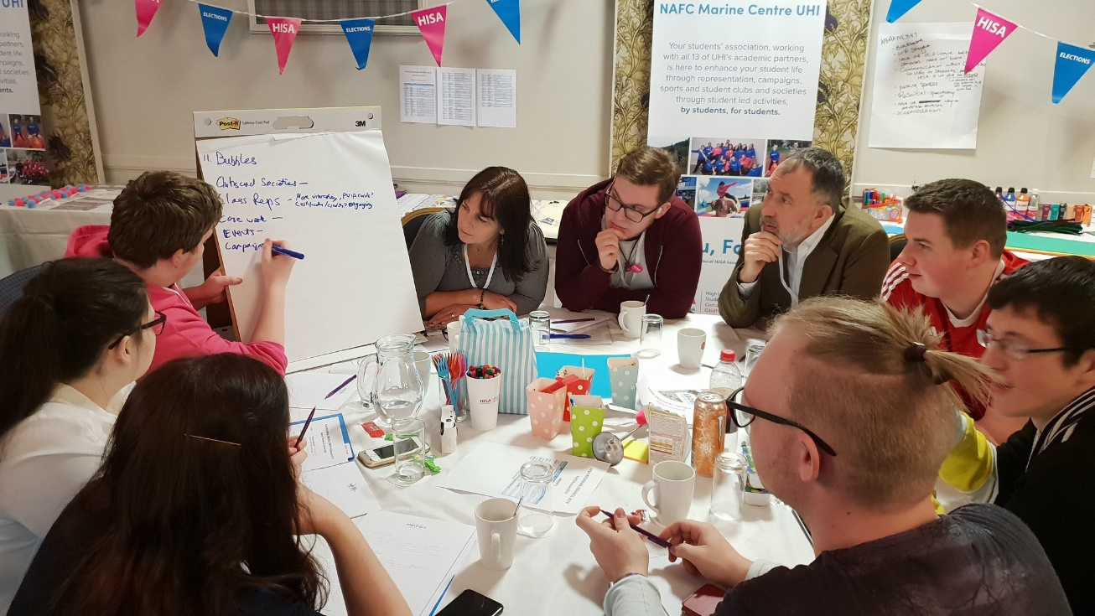
The event was attended by staff and students (HISA officers, deputes and student reps from across UHI) to engage students as creators and users of evidence. There were six interactive sessions, the outputs of which have fed into various other stands of work:
- KPIs: Taken forward by HISA
- Analytics and Engagement indicators: Taken forward separately by KS
- Student surveys: Taken forward by HF, and feeding into project 2, strand 1
- Student representation: Taken forward by HISA
- Representation for online and networked students: feeding into strand 2, project 1 below
- Closing the feedback loop: feeding into strand 2, project 2 below

Project 1: Enhancing belonging and representation for online and distance learning (ODL) students
This project involves several online programmes within the Applied Life Studies subject network and aims to enhance the student representation system, and use student reps as a focus for improving students’ sense of belonging. The following activities are taking place within this project:
- Focus groups with students during March 2019 to gauge current views of student representation
- Reorganisation or consolidation of the student rep system based on the findings from the student focus groups
- Recording of videos of academic staff and student reps explaining the aims of the student rep system and the benefits of becoming a student rep
- Creation of a Learning Communities Special Interest Group to bring together staff members and enhance practice in this area.

Project 2: Closing the feedback loop
Emerging from the student rep summit were the lessons about closing the feedback loop with students. These will be taken to the Student Engagement Group in June 2019 with actions taken forward thereafter.

Internal work: Strand 3
The overall aim of work within strand 3 is to support student progression through innovative and effective use of assessment feedback with subsidiary aims of supporting students to use feedback cumulatively and collectively, and helping students to understand when they are receiving feedback.
Emerging from the Year 1 benchmarking report was the following suggested area of focus for pilot projects within this strand:
- Embedding and piloting principles for effective and innovative practice within assessment feedback which are outlined in the academic literature. Evaluating the impact of this in a range of disciplinary contexts.

Events
As part of strand 3, we organised a two day Assessment and Feedback Symposium across November 29th and 30th which explored several aspects of assessment and feedback practice relevant to our the Enhancement Theme work and to broader assessment and feedback practice within the university. The event featured two external speakers. Professor Peter Hartley delivered an opening keynote on ‘assessment futures’ and ran a workshop on ‘programme focused assessment’, while Dr Moira Maguire from Dundalk Institute of Technology delivered the closing keynote on evidence-based approaches to groupwork assessment. KS ran a workshop on ‘feedback as dialogue’, while various colleagues from across the university delivered ‘best practice’ lightening talk sessions.
The various sessions were recorded, and we expect these recordings and associated examples and resources will contribute to the guidance and exemplars that strand 3 will produce for the university.

Project 1: Feedback as dialogue within different disciplines
Currently we have identified two pilot projects focused specifically on implementing and evaluating approaches linked specifically to ‘linking feedback to progression’, which are the BA Social Sciences and BSc Applied Science programmes. We are working with these programme teams at the moment to develop their pilot interventions for implementation and evaluation in 2019/20.

External work

Events and conferences
External facing work has involved attending and presenting at the following QAA events and conferences:
- QAA Enhancement Theme event, Edinburgh, Dec 2018: Presentation by Cat Meighan, Sorcha Kirker and Heather Fotheringham
- Collaborative cluster event, Heriott-Watt Jan 2019: Presentation by Keith Smyth and Heather Fotheringham
- Edinburgh, Feb 2019: Students as users of data: Presentation by Sorcha Kirker

Collaborative clusters
The University is also part of two sector-wide collaborative clusters. The first aims to provide resources showcasing best practice in creating a sense of belonging amongst online and distance learning students. The outputs from this cluster will be a toolkit containing the following resources:
- A mini literature review
- Videos from tutors and students
- Case studies evidencing best practice from a range of programmes (different discipline areas and different modes of online/distance learning)
UHI is one of four institutions involved in the cluster (along with OUS, Dundee and QMU) and we are leading on the production of the best practice case studies. Keith Smyth produced a template with accompanying guidance. Heather Fotheringham conducted telephone interviews during February 2019 with case study authors. These have been put with the other resources to produce a first iteration of the toolkit which was recently reviewed by nominated staff at each of the participating institutions. The final version of the toolkit is now being refined, and KS and HF are now revising the literature review to be included in the toolkit as a further part of the UHI contribution to this work.
The second collaborative cluster, led by Edinburgh Napier and GCU, is focusing on upskilling module and programme leaders to become effective users and analysts of data for enhancing learning, teaching and the student experience. The second cluster involves a wide range of universities contributing to the work in various ways. To date, then in addition to providing input to scoping the work of the cluster and presenting at the Herriott-Watt event on Jan 2019 we are also planning to contribute a short case study relating to our own work in evidence-based practice to the outputs of the cluster. HF is also participating in the final event of the cluster on 15th May 2019.

