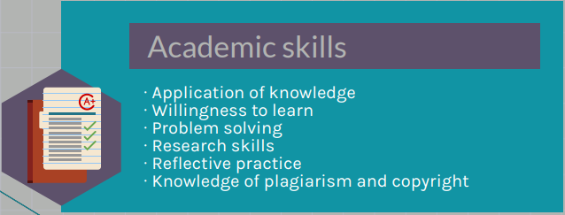

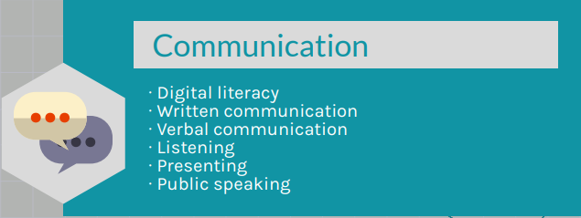

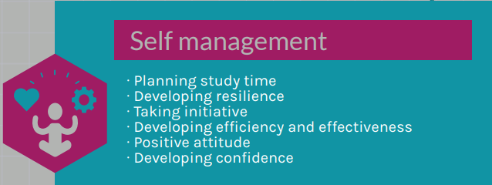

The academic skills I have developed through my studies are …..

A good example of my academic skills is ……

I am going to further develop my academic skills by …….

The communication skills I have developed through my studies are …..

A really good example of my communication skills is ……

I am going to develop my communication skills by …….

The self-management skills I have developed through my studies are ..

A really good example of my self-management skills is ……

I am going to further develop my self-management skills by …….

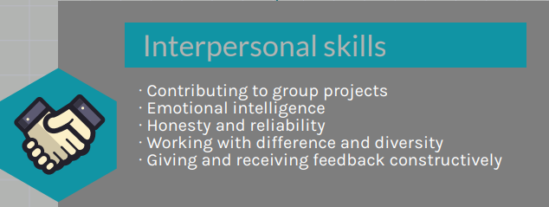

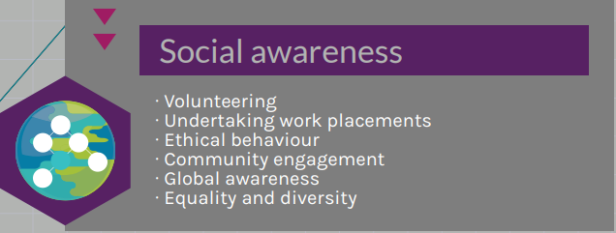

The interpersonal skills I have developed through my studies are …..

A really good example of my interpersonal skills is ……

I am going to further develop my interpersonal skills by …….

The social awareness skills I have developed through my studies are ..

A really good example of my social skills is ……

I am going to further develop my social skills by …….