
Focus piece on graduate attributes

The following format is suggested as the basic structure for a focus piece on your use of the graduate attributes. A central theme of the graduate attributes is that they accommodate diverse subject areas, levels of the curriculum, academic colleges and employers. This diversity will be highlighted through the sharing of examples of the use of graduate attributes from across the university. The focus pieces will have a home on the Learning and Teaching Graduate Attributes web pages and can be linked to and shared by colleagues, students and employers.

Title
[Please provide a short title for your focus piece]

Date
[Please add date of submission to the LTA]

Author’s name(s) and role(s) and location(s)
[Please include the names and relevant information of those involved in the focus piece]

Relevant Icon(s)
[Please delete any icons that are not directly relevant to your focus piece]
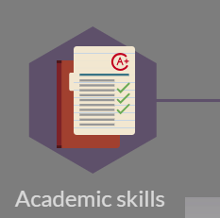





How have you made the graduate attributes meaningful to you in your context? [Please briefly describe the context within which you work and how you have used the graduate attributes to enhance the student experience.]

Why has a focus on the graduate attributes been particularly effective?
[Please share your reflections]

Have you had any feedback on your use of the graduate attributes?
[Please provide any information on feedback you’ve received.]

What the main message you would like to share from your own experiences of working with the graduate attributes?
[Please provide a sentence or two on the main message you would like to share with colleagues.]

Images / videos / resources / links to resources
[Please provide supporting media files (images, links to videos or resources) which support your focus piece. If you would like any assistance with medial files, this can be provided). Please provide related Audio Visual Release documentation. If you need assistance with this please let us know.

Lastly …
[Please share any other reflections on the value of the graduate attributes]

Submission
Please send the completed form to LTA@uhi.ac.uk for publication on the LTA’s Graduate Attributes web pages. If you have any queries please also email LTA@uhi.ac.uk . Thank you for taking the time to share your work with the graduate attributes.
Supporting innovation through the University’s Graduate Attributes

