WHY IS GETTING TO THE DOCTOR SUCH A HASSLE?
There is a little village in rural Hungary, Tarnokreti, where only two buses per day transport people to the nearest town. One in the morning and one in the evening. There is no constant medical service; the GP visits the settlement once every week. For years, receiving more complex care or even for an X-ray, patients had to arrange some means of transportation – if they didn’t want to wait for hours for the bus. However, being in need of support from relatives or friends with cars causes much discomfort – so many people decided they were rather not going to the doctor’s appointment.
The problem is well-known in many parts of the world. No matter whether in Europe, the US or South Asia, people living in rural areas, but also more impoverished people in suburban and urban settings, can have trouble with transportation. Some households don’t have a vehicle or share one among multiple family members. Moreover, for those who are disabled, obese, or chronically ill, riding the bus or the subway can be a difficult undertaking.
John Lewis, CRO of Circulation, a platform that sets up transportation of any kind for patients to ensure they make it to their doctors’ appointment, told The Medical Futurist that transportation barriers are a leading cause of gaps in healthcare in the US. Each year, around 3.6 million patients miss at least one medical appointment due to lack of access to transportation.
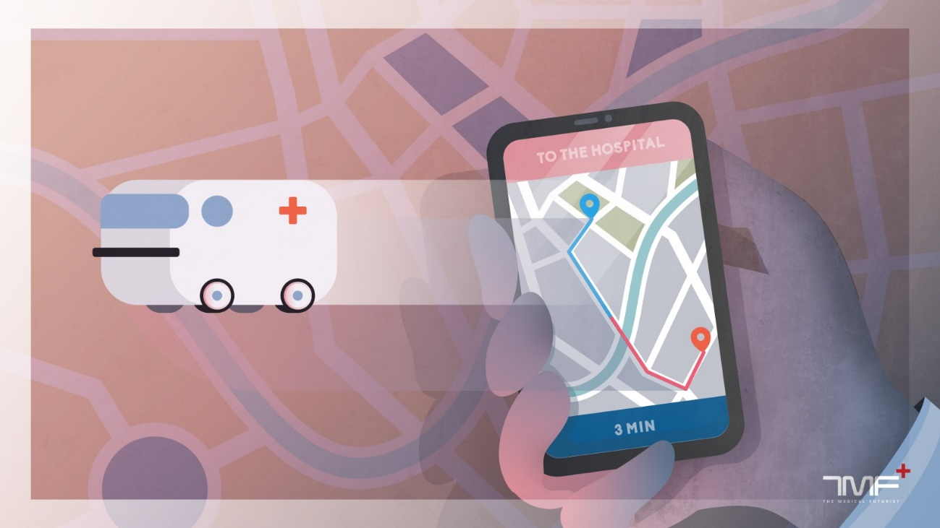
Possible solutions: the US and CHWs
Some years ago, the mayor of Tarnokreti had enough of people complaining about not receiving the appropriate medical care, so the municipal council bought a bigger vehicle, and now, everyone who has a doctor’s appointment could get a ride to the nearest town.
As The Atlantic writes, each state in the US has a “non-emergency medical transport” benefit for people with Medicaid, covering a certain number of rides per month, and some Medicare Advantage plans also include a limited number of trips each year. Some states contract with local companies to provide rides; others enlist volunteers or hire taxis. Some private insurers also have transportation benefits, but there might be some preliminary conditions to meet or may involve co-pays.
There is also the system of community health workers (CHWs), who help patients navigate the healthcare system. CHWs, who typically don’t have health-care backgrounds, will coordinate transportation for patients to and from appointments, motivate them to take their medications, and help them implement positive lifestyle habits. In 2014, there were an estimated 50,000 CHWs in the U.S.
In Europe: the government hand-in-hand with hospitals
In the UK, when patient transport service (PTS) is required, healthcare providers will connect their patients with an appropriate service provider. The government provides some regional PTS services through National Health Service ambulances. However, currently, small and large private businesses run most patient transport services in Britain. Yet, the system has serious flaws: patients have to wait long hours, miss the appointments, etc. In 2014, some organizations even launched a campaign called Sick of Waiting to change the situation.
In France, patient transportation services are provided in three different ways, by ambulance, by light medical vehicles (VSL) and by taxi. When a patient needs transport to or from a doctor or hospital, they can take a cab, VSL or ambulance, then make a claim to Social Security and be reimbursed. The patient’s facility or physician chooses whatever approved service with which they have contacts. In the past few years, this model has been attacked by the French government because of the spiralling costs of taxis.
Yawning gaps to fill
So far governments, healthcare providers and traditional businesses contracting with medical facilities for patient transportation could not give a comforting solution to the issues of getting patients to their doctor’s appointment on time. High costs, long waiting times, missed visits, poor communication, and administrative affairs – the list of downsides is too long. Too many people experience transportation barriers in healthcare and a too big market niche, which cannot be left out of sight.
However, it was a difficult question whether ridesharing businesses, such as Uber or Lyft could disrupt healthcare the way they did with taxi services. As the latter was unreliable, inconvenient with high prices, while the entry barriers to the market were not that high, Uber swept the transportation landscape. The company has proliferated, spreading to more than 150 U.S. cities and 58 countries, with an estimated valuation of $62.5 billion.
Although entry barriers are higher in healthcare-specific regulations, industry standards and costs -, not only Uber, but also Lyft and many other start-ups considered it as worthy to enter the non-emergency healthcare transportation market, and offer reliable, cheap services.
Uber moves into top gear
Dr. John Brownstein, chief innovation officer at Boston Children’s Hospital, first came up with the idea that Uber could be used to fill gaps in patient transportation in late 2013, wrote Jaimy Lee for LinkedIn. Brownstein left a comment in the app after a ride, and Uber called him back. Three years later, he co-founded Circulation. Since then, the start-up has established 70 partners in 46 states and facilitatesd transportation to over 1,500 clinical locations across the US. They partnered with Uber in 2016, and Lyft in 2017, as well as local transportation providers such as wheelchair van fleets. “We have had an extremely positive response to date. Patients appreciate the dramatic improvement in patient access, and respond favourably to the fact that we are bringing the modern conveniences they expect in everyday life to healthcare”, said Lewis.
Uber got apparently interested in the healthcare space in the last two-three years. After teaming up with Circulation, the company hired a veteran lobbyist in Washington, DC, to pursue the ride-hailing company’s agenda on policies related to health care and medical records privacy. Then in March 2018, Uber launched its own platform, Uber Health, allowing healthcare organizations to schedule transportation for their patients. To make their service more accessible for people not using smartphones, they introduced the option to call or text the company to schedule a ride. Over 100 healthcare organizations in the US, including hospitals, clinics, rehab centers, senior care facilities, home care centers, and physical therapy centers are already using Uber Health – and we assume it will be many more.

Lyft and start-ups eager to fill the niche, too
Uber’s biggest competition in the US, Lyft doesn’t want to lag behind either. The ride-hailing service introduced its concierge platform to health-care providers a little over two years ago so doctors’ offices and hospitals could order transportation for people. It has since signed deals with several hospital systems and medical transportation companies. In May 2017, Blue Cross Blue Shield Association announced a partnership with Lyft, to provide the option to patients to get to their local pharmacies by car to pick up their prescriptions or to arrive at their primary care appointments on time. As its latest move, in March 2018, it partnered with Allscripts, a health IT platform provider. The company integrated Lyft’s platform into its own system, which will allow the doctors and hospitals that use Allscripts’ electronic health records to make pickup appointments for their patients.
Start-ups are also not wasting their time when it comes to transportation in healthcare. Beyond Circulation, there are a handful of companies offering similar services. Mindi Knebel discovered the problem of finding affordable transit to access healthcare from both sides of her family living in rural Iowa and urban Chicago, so she co-founded Kaizen Health. The start-up partnered with Lyft and offers a wide range of vehicles. Another similar start-up, San Diego-based Veyo currently provides rides for Medicaid beneficiaries in eight US states. Ride Health, SafeRide, Round Trip or Ambulnz also aim to take part in rebuilding the US medical transportation industry.
What are the challenges in ride-hailing in healthcare?
The Medical Futurist believes there will be many more start-ups and platforms in the following years which aim to disrupt the healthcare transportation field in the US. There are even useful tips and recommendations about how to start a non-emergency medical transportation company out there. Moreover, these companies might get to Europe in more numbers as well, against all the challenges the healthcare transportation landscape poses with regulations and traditional supplier companies. The reason is simple: they are reducing costs and improving care.
However, there are serious issues which all ride-hailing companies should take into account when entering healthcare. What happens in case of a medical emergency during a ride? From Uber, Lyft until Circulation, every one of the concerning businesses said they are focusing on non-emergency transportation. Lewis told The Medical Futurist, the drivers don’t provide medical attention during the ride to the hospital or doctor’s appointment. Nevertheless, as the number of ride-hailing services increases, the statistical chance of a medical emergency goes up, too.
Although Lewis explained that Circulation’s platform is not just meeting the patient’s transportation needs, but also their medical requirements which can be matched with the timely, convenient and reliable delivery of caregivers, equipment or drugs, they should also focus on medical needs during rides.
No one should wait for a case similar to what happened with a self-driving Uber car. As the ancient saying goes, it is better to be safe than sorry. And while The Medical Futurist does not think that Uber, Lyft or any of these start-ups providing non-medical emergency transportation will move into emergency transportation services, there are certain steps with which they could ensure patients’ peace of mind. There are already technologies out there to prepare for unexpected events. Portable diagnostic devices, fast communication as well as appropriate protocol could mean a safe background no matter what happens.
Overall, ride-hailing platforms seem to have found the niche where they could genuinely flourish while solving a painstakingly costly and insurmountable problem for patients. Non-emergency medical transportation services mean a more reliable and affordable means of getting to the doctor’s office for many people in rural or urban areas without appropriate infrastructure. The Medical Futurist hopes that their service will be a common practice in every corner of the world soon.
Source: The Medical Futurist℠ Newsletter, April 2018
http://medicalfuturist.com

