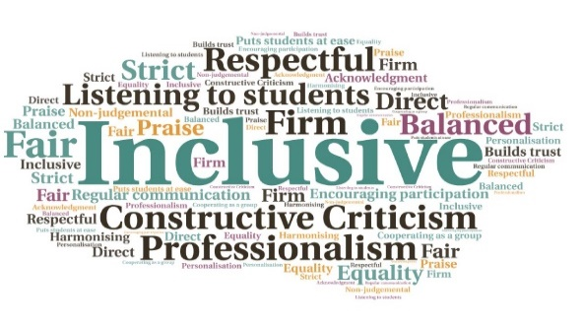  “Following the counselling I feel more supported, I feel like I can open up to my close friends and family about the problems I am facing.”  "I would have felt too scared to have a face-to-face session, I found the messaging service enabled me to move on with my life. “  Increase in the number of students who were high risk | Provided more flexible support | Utilised different systems, including video conferencing and text messaging | Use of individual sessions resulted in fewer wasted appointments| Changes led to the service operating without a waiting system in Semester 1 | Staff were still able to respond to students in crisis, despite not being on campus  Adapting the Inverness College UHI Counselling Service for the Covid Pandemic  Inverness College UHI  W | Goal: Adapt the existing counselling service during the pandemic restrictions to provide the same level of support using just online resources.  Submitted by: Susan Dale  Project: To replace face to face counselling and drop-in sessions with an online services to be delivered by staff working from home during lockdown.  Benefit to: All students  Key message: Provide the same level of support whilst campuses are closed  To provide a stepped approach to mental health care that ensures students are able to access appropriate support swiftly  To address concerns around poor mental health and suicidal thoughts and behaviours, exacerbated by the pandemic  To make the service user friendly  To adapt to having fewer counsellors available  To ensure the same level of support is provided using online resources, with staff working from home  Project delivery  Creation of an adaptable services that offers, post-triage, individual counselling sessions by video or phone call, bookable on an ‘as and when needed’ basis  Daily online drop-in slots, to respond to students in crisis  Direct links to Wellbeing workshops and resources  A series of counselling sessions are available when appropriate, for more complex mental health concerns  E-therapy available, either as synchronous texting conversations via Webex Teams or as asynchronous conversation by email  The stepped approach has enabled the team to deal more effectively with the steep increase in referrals for students presenting at the highest level of distress  Impact: Students have indicated via feedback and evaluation that they have felt supported and appreciated the flexibility of the service. The team were also able to deal with the significant increase in students presenting at the highest level of distress, including those at high risk of suicide or self-harm.

