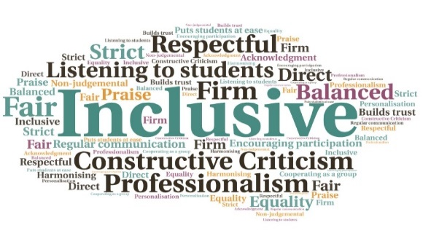  “I found the parts about funding, ID and downloading the different software particularly useful.”  "Such a good tool. It can be hard to cover everything in the 1hr a week Guidance Sessions, and having this resource is very helpful for students to work through during study slots and ensures important information isn’t missed by the tutors. “  Evaluation and feedback will lead to improvements, year on year | Students can access the resource at any time, not limited to induction| Local centres can personalize information | Video clips enhance written content| Staff found it a better way to disseminate key information | Ensures consistency, and helps prevent important information being missed  Brightspace Induction Module  Argyll College UHI & West Highland College UHI  W | Goal: To develop an innovative, personalised Brightspace Induction Module which would meet the need for a new approach to college student services inductions for 2020/21, due to Covid19 restrictions  Submitted by: Lesley Hawkins (WHC), Anne-Maree Dykes (WHC), Liz Richardson (AC)  Project: The creation of an online module which would replace face-to-face inductions and include information about student services as well as covering centre specific orientation, to be undertaken a week before teaching begins.  Benefit to: All students and staff  Key message: Provide students with a full online induction  Adapt existing materials and produce new materials to populate a specific Brightspace module  Replace traditional face to face inductions, to be used during events such as the Covid19 pandemic but also for distance learners  Utilise cross-partnership skills which will result in a more resilient and creative development team for the project  Inspire staff to contribute to the project, with a partnership-led approach  Ensure the resource is highly accessible with the potential for future enhancements, to be used by students on an ongoing basis  Project delivery  A member of staff with strong Brightspace skills was identified, to lead the initiative  Consideration was given to the information required by students at induction, with material gathered from a widely dispersed spread of staff and centres  The resource took just over 6 weeks to develop, which included interactive quizzes and recap materials  Care was taken to ensure videos and documents had the same consistency and branding, as well as meeting student needs  The resource will be useful for partners with distributed rural centres, and has the advantage of being available 24/7 for students to refer back to  Impact: A large majority of students accessed and engaged with the resource, with 94% of those agreeing it contains useful information. Students who accessed all of the areas also had less problems and/or queries. Teaching staff meanwhile found it a useful resource to signpost students to.

