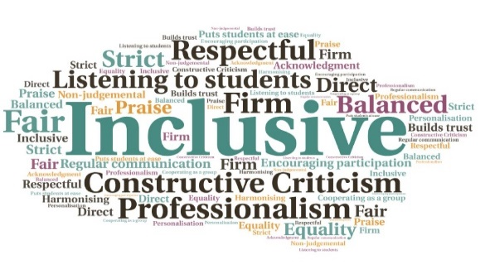  “The relationship is incredibly valuable to HISA. Our partnership working has opened up new pathways for our officers as well as better support for our students and more visibility of the fantastic services offered by the Careers and Employability team, enabling our students and officers to make informed decisions and having a point of contact not only during their studies but also through the graduates for life scheme.”  Collaboration between the CEC and HISA | Access to required tools for navigating the post-Covid labour market| Workflow guides students through a framework of employability-related activities and tasks | Levels include questionnaires and skills, strengths, and values exercises| Links with current QAA Enhancement Theme ‘Resilient Learning Communities’ | Link with HISA increases strength of messages to the student body from the CEC  HISA Officers Career Development Pathway  Executive Office | Goal: Create a suite of resources and interventions to support HISA Officers, as well as the wider student population.  Submitted by: Helen Anton/Iain Eisner: Careers and Employability Centre  Project: To prioritise employability skills within the student association by creating a new and innovative online career development module for HISA Officers.  Benefit to: HISA Officers and the wider student population  Key message: Creation of online resources for HISA Officers  Create an online module with a series of predetermined workflows to guide students through activities and tasks  Ensure HISA Officers can articulate the knowledge and attributes gained through their tenure, for increased employability  Increase collaboration between the Careers and Employability Centre (CEC) and HISA  Meet the need for students to have easy access to tools required to navigate the post-Covid labour market  Improve the knowledge of HISA Officers to enable them to signpost students to the CEC and promote the support available  Project delivery  Development and launch of the HISA Officers Pathway, enabled through the FutureMe career management platform  Collaboration with HISA to raise awareness and strengthen the messages promoted by the Careers and Employability Centre  Content aims to address some of the concerns around a post-Covid employment landscape  Resource is structured, but allows users to undertake their learning at a time which suits them  Strengthens the relationship between the CEC and the student association, which is unusual compared to other Scottish universities  Impact: The creation of the resource recognises the development of employability skills as a priority, both within the student body and HISA itself. This will support Officers and the wider student population.

