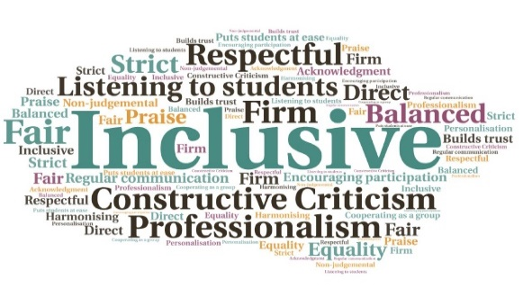  6,270 loans across the partnership from Apr 20-Jan 21 | 12,607 views of Libguides during lockdown | 440 LiveChats between Jun 20-Feb 21 | 685 new e-books purchased | All academic partners now able to supply a Freepost return service | Local Covid-safe study spaces, where restrictions permit  Library Services During Covid  Executive Office | Goal: To provide students with access to resources and advice on library matters, despite restricted access to college buildings.  Submitted by: Ruth Priest on behalf of the Library Practitioners Group  Project: Ensure the negative impact of lockdown on library services is mitigated, and adapt services to ensure students continue to have access to the resources they require for their studies.  Benefit to: All students  Key message: Continued access to library services during Covid  Work across the partnership to deliver an adapted service  Creation of new services in a joined-up manner  Expansion of e-book provision  Automatic loan renewal and deletion of fines for late returns  Provision of Covid-safe study spaces, where possible within local restrictions  Project delivery  Click and collect services set up for print books and copies also sent by post, with costs covered by the university. Freepost set up across Partnership to allow students free return of Library items  Increase in spend on e-books; an additional £30,000 made available  Live chat service set up from June 2020 onwards  Creation of short videos as an easy, visual guide to using library resources. New Libguides also published regularly, giving up to date information  Libraries assisted with the distribution of laptops to students, supplied by both local IT and central funding routes  Impact: Students have been provided with continued access to the texts and materials they require for their studies, despite ongoing lockdown restrictions. A number of the services developed will continue once restrictions are lifted, enhancing the existing provision.

