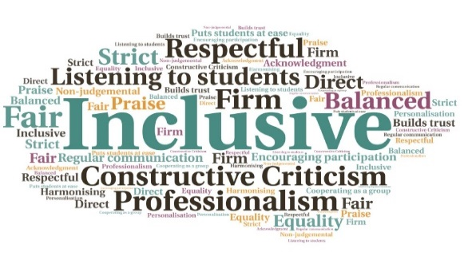  Option for Viva exams by video conference | Enabled PGR students to complete their course, despite Covid restrictions | Alleviated potential anxiety caused by delays in final examinations due to the pandemic  Postgraduate Vivas by VC  Executive Office | Goal: To allow Postgraduate students to have their Viva exams by video conference, during the pandemic restrictions  Submitted by: Jackie Deacon  Project: Implement a new process and create guidance for PGR students to have their Viva exams by video conference rather than waiting until face to face exams can be resumed.  Benefit to: PGR students  Key message: Hold Viva exams by video conference  Swiftly arrange a new process for Viva exams due to lockdown restrictions coming into effect in March 2020  Prepare guidance and create an application form for the process  Communicate new option to students, who can choose to engage or wait for face to face exams to resume  Allow PGR students to continue to complete their course during the pandemic  Project delivery  Guidance and an application form for the new process were created at the start of lockdown  All PGR students approaching the end of their course were offered the chance to have their Viva exam by video conference  More than 20 students agreed to the process, which prevented significant delays in their final examination  The option helped to alleviate potential stress and anxiety caused by the impact of the restrictions  Impact: All students who were offered the video conference option chose to take it. It is anticipated that this will continue during the on-going pandemic restrictions. External examiners praised the speed with which the new process was implemented.

