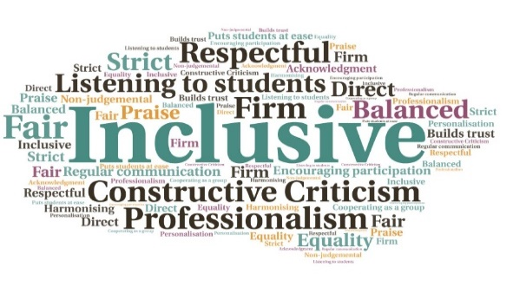  “Weekly catch ups with Student services were/are great.”  “Good communication between curriculum and support staff seemed key to this – some additional support needs are emerging and being addressed swiftly.”  Clear focus on collaborative support | Staff are better placed to identify and develop support options| Student issues are dealt with swiftly | Closer relationship between curriculum staff and student support teams| Provides an alternative to informal staff catch-ups on campus | Builds on ‘one college one team’ approach  Pre-emptive Triage Support for Students  West Highland College UHI  W | Goal: To identify student related issues at an early stage, and build closer relationships between curriculum and support teams.  Submitted by: Lesley Hawkins on behalf of WHC Student Services team  Project: To create a process which enables staff from curriculum areas and student support teams to regularly meet to discuss any issues, share good practice, and build on the ‘one college one team’ approach  Benefit to: All students  Key message: Foster pre-emptive support for students  Provide a regular and safe space to discuss low-level issues  Replace the face-to-face informal discussions which would usually take place on campus  Create regular opportunities for curriculum and support staff to liaise  Utilise online systems while staff work from home  Find ways to efficiently deal with issues arising from the pandemic and subsequent lockdown, such as IT needs  Project delivery  Regular weekly meetings scheduled between student support teams and each of the curriculum areas  Creation of a Microsoft Teams space for the meetings, which can also be used for conversation using the ‘Chat’ function  Curriculum staff have been able to identify students who are not engaging or who have raised issues, who are then contacted by the student support team  IT needs were quickly identified, and staff were able to work with student funding to complete digital poverty applications  Significant improvements were made around communication and information sharing, on a 2-way basis  Impact: Colleagues have developed a deeper understanding of issues facing different teams and student issues have been quickly identified, with staff working in a joined-up manner to resolve these and provide the required support. The systems in place have continued beyond the initial lockdown period.

