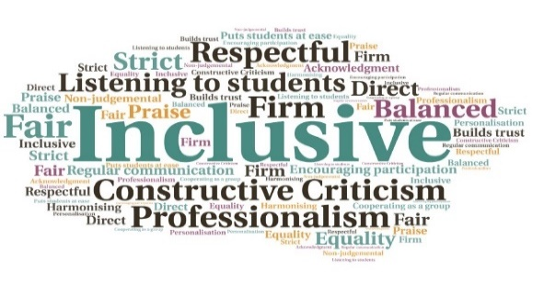  The Webex Arms  Centre for Rural Creativity UHI | Goal: Create an online space for students to utilise for study and socialising, during the pandemic restrictions.  Submitted by: Roxane Permar  Project: To expand on an existing student space and use it to ensure continued engagement with students both academically and socially during lockdown.  Benefit to: Students on the MA Art and Social Practice course  Key message: Promote online interaction and engagement  Create an area where students can exchange information regarding their course and also socialise  Ensure continued engagement with students whilst study is entirely online  Encourage collaborative working  Provide the opportunity for students to interact socially with their peers  Ensure students continue to be sufficiently supported  Project delivery  Students used an existing online space, which they named the Webex Arms, to set up daily drop-in sessions to support one another  Staff started a twice weekly group ‘write-in’, comprising two 24 minute sessions  Students arranged an online pub quiz  During the Spring break, three talks were given on different topics, one from a staff member and two from PhD students  Additional talks were arranged, with external speakers  Impact: The space provided students with an opportunity to access mutual support within their cohort, as well as enhanced bonding and friendship. It improved overall well-being and helped to ease anxiety and upset during lockdown. Students reported finding new resilience and confidence, and positive ways forward for their learning and work.
Naming of the space gave it a positive identity | Collaborative learning was encouraged, e.g. meeting in small study groups | Helped students take responsibility for their learning | Tackled the issues relating to lockdown in a positive way | Increased focus on certain tasks, for instance through sessions on writing techniques | Students have ownership of the space and are keen to continue to use it going forward

