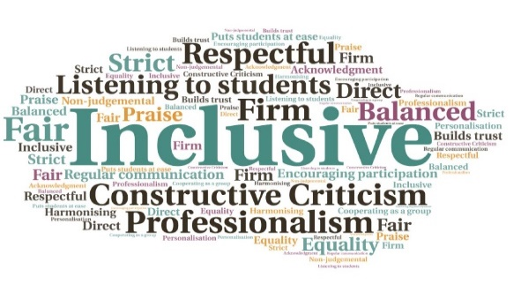  83% of students passed the first five learning outcomes | Student engagement has continued, despite the move to online learning | The app has resolved some of the issues with lack of practical course elements during lockdown | The blend of learning elements has ensured students continue to submit coursework on time and achieve good results | Encourages collaborative working among the cohort | The app is used by Open University, allowing staff to benchmark their practice against that used by experts in distance education  Use of Multisim Live  North Highland College UHI | Goal: Find a way to enhance the online experience of students unable to do practical laboratory work due to the pandemic restrictions and closure of campuses.  Submitted by: Adrian Mackay  Project: To utilise online technology to engage students who are struggling to study fully online due to lockdown.  Benefit to: All students  Key message: Enhance the online learning experience  Find a method to deliver practical elements of the course while working fully online  Enhance student skills in an innovative manner  Ensure students can share their work using secure methods  Encourage collaborative working  Ensure continued student engagement with the course  Project delivery  A free, online app was utilised which can be used for circuit drawing and for simulations  The app allows students to design and test circuits in a safe environment, which has encouraged more active learning  The app is industry-standard, which gives students the confidence and ability to contribute in a digital environment  Groups were set up for students to share their circuits, encouraging collaborative learning  Use of the app during classes encourages creativity, communication, and problem solving skills  Impact: Students have adapted well to the blend of online lecturers, Brightspace material, and use of the app. It has ensured that, despite the impact of Covid, students are still acquiring technical knowledge, communication skills, digital technology skills, and team-working skills, in a project based environment.

