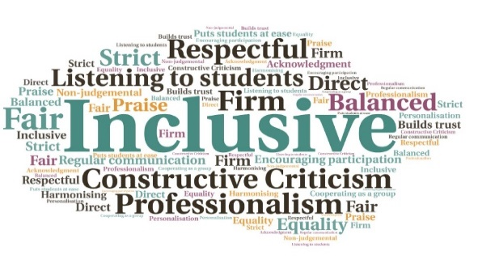  Provide a sense of community for students | Give access to direct feedback from successful artists on the process of making records |  Aff the Record Podcasts  UHI Perth | Goal: To create a greater sense of community across the UHI creative industries and discuss the underlying thought processes of musicians and producers in how they create successful records.  Submitted by: David Paterson  Project: Create a half-hour podcast of conversation and music that demonstrated to students that success in the music industries requires motivation, creativity, and critical judgement.  Benefit to: All music and audio students  Key message: Increased sense of community  Interview a variety of people from the music industry  Discuss the creative process of making records  Guests to share their favourite records and describe working on them  Create a greater sense of community across the Creative Industries network  Provide students with a realistic sense of what is required to be successful in the music industries  Project delivery  Recording of interviews via Zoom  Interviews edited and distributed to all UHI music and audio students through a Brightspace module  Impact: Informal feedback indicates the podcasts were widely accessed and enjoyed by both students and staff during the 20/21 lockdown.

