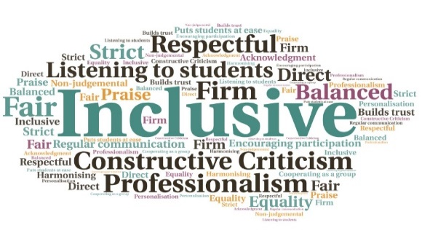  13 students started the course | 3 students were temporarily reassessed and moved to other transitional programmes | 95% attendance over the 3-day course | Increased engagement with education | Students felt supported by staff and by their peers on the course| Useful life skills covered included cooking and sourcing best contracts for utilities  “I didn’t think I’d ever be able to come to College and I have had no other opportunities because of covid. Since covid I have just felt so sad, I would just get up, eat and play on my Xbox then sleep and repeat. The LEEP Ahead programme was the best ever news. I was told that I could never go to college but now my life has changed, I want to see if I can become a joiner”  “I just couldn’t manage the online learning and felt so unmotivated. It affected my mental health. This face to face programme has given me the confidence to try again”  LEEP AHEAD Programme  UHI Inverness  W | Goal: To ensure care experienced young people, identified at high risk of negative outcomes in life, are provided with an opportunity to thrive and acquire experiences and qualifications which will allow them to successfully progress onto further education and training and/or gain meaningful employment in the future.  Submitted by: Louise Martin-Theyers  Project: To develop mental health awareness, support independent living, challenge bias and stereotype, and promote a sense of self.  Benefit to: Care experienced young people aged 18-26  Key message: Embed a discrete curriculum of core skills to combat barriers  Run a bespoke 2-year pilot programme on behalf of Highland Council to support non-engaged care experienced young people back into employment/education  Liaise with external providers  Find wrap around care solutions for holiday periods  Work on mixed curriculum projects to introduce students to subjects not previously explored  Transition visits for new students plus daily and weekly debriefs to check individual progress and wellbeing  Project delivery  Creation of a new course founded on pedagogical and developmental theory, professional practice experience, and studies into the impact of trauma on learning  Engagement from wider delivery team including social workers, Highland Council employability team, Barnardos, Highlife Highland, UHI Residencies, and key college staff  Case conferences held for each student and full transition plans created prior to enrolment  Pre-start visits to campus to meet key members of the immediate team  Regular briefings designed to implement timely support  Impact: Students on the course reflected that it had offered them the opportunity to regain structure and routine after the restrictions of the pandemic; during Covid they had little to motivate them and had struggled with their mental health. The course helped them to develop life skills in addition to academic content.

