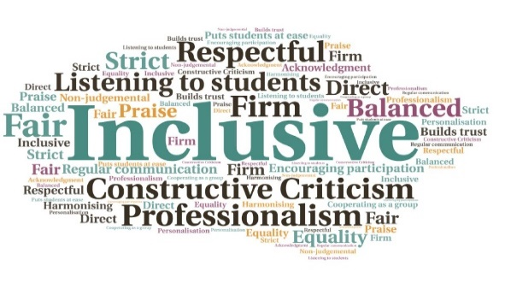  “Very prompt and very helpful - I will definitely use the chat function again where applicable.”  “So glad this service is now here, I can get on with studying rather than spending hours of my time with library queries that I don't know who to turn to with! ”  Information gained through calls used to improve the online help available and amend service provision | Multiple entry points| Offers help to students and staff wherever they are based | Easy to find| Instant responses to simple questions | Signposting for more complicated issues, which saves time  Library Chat  Executive Office  W | Goal: To enhance and improve student and staff use of library resources and services, leading to improved outcomes.  Submitted by: Ruth Priest, Richard Hughes, on behalf of the Library Practitioners Group  Project: To offer ‘business hours’ quick real-time response to library patrons and ‘library counter’ query and help service to non-campus-based students and staff, via an online tool.  Benefit to: All students  Key message: Assist students and staff, wherever they are located  To offer a 9-5 live service throughout the year, except for the Christmas/New Year break  Signpost to online library help for out-of-hours queries  Equivalence of experience for students and staff who are not based on-campus  Discover, measure, and monitor where students and staff have issues with finding and using library resources and services  Project delivery  Acquisition of a new live enquiry services, LibAnswers launched at the start of 21/22  Staffed by members of the UHI Library Practitioners Group, on a voluntary basis  Links to LibGuides online, so even when not staffed callers can search for information or leave a ticket  Multiple entry points, with pop-up boxes and widgets on most of the library online pages  At busy periods, there are multiple staff members available from across the partnership  Informal; first names are used and the tone is friendly, chatty, and non-jargon based  Impact: During 2020/21 a Servicedesk-owned system based on a similar model received 672 chat queries. LibAnswers has received 944 chat queries from Sept 21-Feb 22. The tool has been particularly useful during Covid lockdowns, but will also fill a gap for distance and other students who are not often on campus. Where ratings are left, they have been overwhelmingly positive.

