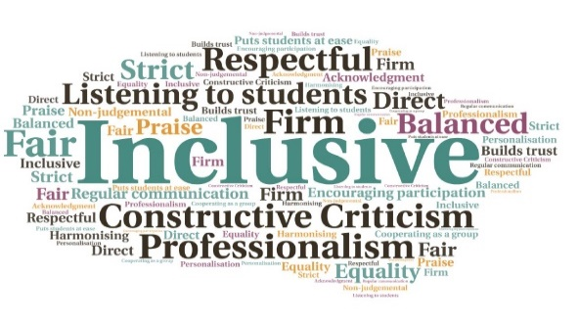  “Staff responsible for learner funding have created a helpful video for learners, made available online, which explains clearly how to complete the bursary application process and seek any further support. This is now being used extensively by other UHI colleges, and has been particularly useful for care-experienced learners applying for bursary support” (Education Scotland)  Easy-to-use tool for learners, accessible for all | Meets accessibility requirements | Can be replayed or paused when completing an application | Embedded within funding letters and emails | Used across the partnership | Enhances induction  Visualise How to Complete Your Funding Application  UHI West Highland  W | Goal: To help students receive their funding quickly by submitting correctly completed forms with all the evidence required.  Submitted by: Anne Maree Dykes  Project: To create an easily available, step by step funding video.  Benefit to: All students  Key message: Correct completion and submission of funding applications  To alleviate the difficulty some students have when applying for funding  Provide a correctly completed form and necessary evidence, to reduce delays  Ensure students receive their funding in a timely manner and reduce the number of queries and delays  Relieve the burden on staff to deal with incorrect forms and missing evidence  Encourage student’s independence  Project delivery  Creation of a video with slides and a voiceover, to take students through the funding application  Video is short and meets all accessibility requirements, including the use of subtitles  Easily accessible via partner and UHI websites  Video embedded within the funding letter/email which is sent by admissions when an offer is made  Students are applying for funding prior to starting their course, so it is in place early  Inclusion in Brightspace induction module  Impact: Since being uploaded in July 2021, the video has been watched by 1471 people, with peak views between Aug-Oct at 50 in one day. The video has also increased the amount of time students are spending on the Funding webpage, and submitted applications are now containing the correct supplementary evidence. Education Scotland highlighted the video as an area of positive progress in their 2022 visit.

