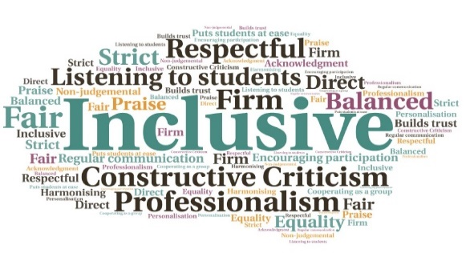  “Great, interesting, and fun. Liked working in a team. Eventful - enjoyed using practical skills. Rewarding, satisfying, relaxed learning. Nice to meet new people.”  Student engagement was very high | development of employability skills| Experience of working within a competitive environment | Encouraged individuality in design | Opportunity to develop practical skills | A different approach to learning  Engineering Project Week  Executive Office UHI  W | Goal: Creating a ‘non-teaching’ week where students can access activities ranging from industry speakers, honours year student presentations, problem solving, and an industry-focused site visit.  Submitted by: Bob Smith  Project: To set up a Project Week which will help students engage with the course in a more exciting way.  Benefit to: Targeted degree students on an engineering programme.  Key message: Enhance transferable skills  Work with an external agency to arrange an industry-focused site visit.  Arrange guest lectures from industry speakers.  Ask year 3 and 4 students to give project presentations.  Boost transferable skills including team working, negotiating, and communication.  Encourage creativity by asking students to design, build, and test an engineering problem.  Project delivery  Creation of an initial pilot at Perth College UHI for year 1 and 2 engineering degree students.  Selection of a winner for Best Design.  Organise presentation by HIAL.  Organise visit to a local industry-focused site.  Impact: The intention is to make this event a non-credit bearing module for the Aircraft Engineering programme. To discuss how this initiative could be beneficial to your community please contact Bob Smith

