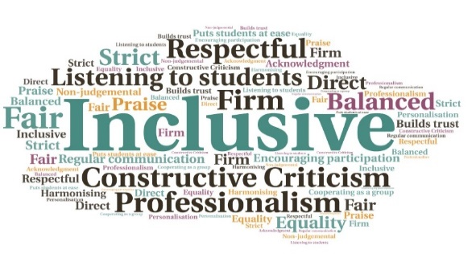  “The 7 clubs who access the facility are delighted it can again be used as it was meant to be.”  Presentation of plaque to students on behalf of local Cricket Club | Students presented to all stakeholders involved in the project, upon completion| Goodwill generated between the students and local groups | Course emphasised development of non-academic skills|  Future Focus  Moray College UHI  W | Goal: Provide an opportunity to refresh, improve, and enhance an array of academic, vocational, and employability skills for 19-24 year olds.  Submitted by: Heather Henderson  Project: To deliver a course which focuses on students taking responsibility within a project, giving them experience and training in both an individual and team context.  Benefit to: Students aged 19-24  Key message: Development of employability and inter-  personal skills  Create a project which will benefit the local community and make a positive impact, impression, or change.  Help students to present their plan to external organisations who will use the chosen facility.  Develop student’s confidence to progress in the world of work or further training.  Create an environment where students improve their inter-personal skills combined with teamwork and leadership.  Encourage student engagement.  Project delivery  Refurbishment of Pavilion and Boat Hut chosen as the project focus.  Obtain free materials from local organisations.  Arrange for students to work in small groups, to encourage peer support and motivation.  Liaise with local groups who use the facilities.  Impact: The facilities are now being used again by local clubs. To discuss how this initiative could be beneficial to your community please contact Heather Henderson

