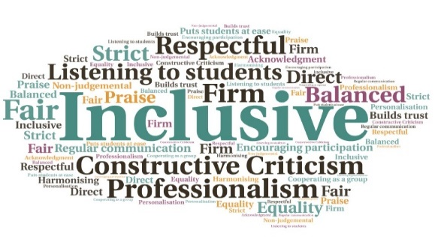  “I felt that it was very helpful and I have been able to use what I was shown to improve my own resilience and pass it on to classmates and others.”  “I found the Decider Skills training hugely informing and helpful. It is a very straightforward resource to use and is certainly useful in terms of its ability to empower students and staff to regulate their emotions and manage mental health difficulties. “  Students gain experience of leading groups | Completion of the training and subsequent workshop delivery enhances student’s CVs | Builds on presentation skills| Students recognise the need for resilience | Encourages different groups to interact  Peer Educators  Inverness College UHI  W | Goal: To carry out health promotion work and explore the application of peer education in building/increasing resilience in the student population.  Submitted by: Claire Kilburn-Young  Project: To invite students with an interest in this area to be trained to deliver resilience workshops, which would normally be run by the Guidance Team. An additional pilot scheme would train 3rd/4th year psychology degree students to deliver ‘Decider’ training (skills to understand and manage mental health) to specific FE classes.  Benefit to: Staff and students  Key message: Build and increase resilience in students  Resilience training to be delivered by members of the Guidance Team.  Observation of resilience workshop delivery followed by co-facilitation then leading a session, once training complete.  Deliver both distinct workshops to all FE classes and first year HE classes.  Free ‘Decider’ training to be provided by NHS Highland.  Students volunteering as peer educators will be recognized for their efforts.  Project delivery  Resilience training undertaken by 4 students, with 2 successfully completing the project.  ‘Decider’ training completed by 4 students.  Additional training sessions arranged for support staff.  Regular staff training sessions to be offered through the year.  Skills to be embedded as part of the whole college approach to mental health  Impact: Staff and students have reported using the skills they learnt, as well as passing them on to others. To discuss how this initiative could be beneficial to your community please contact Claire Kilburn-Young

