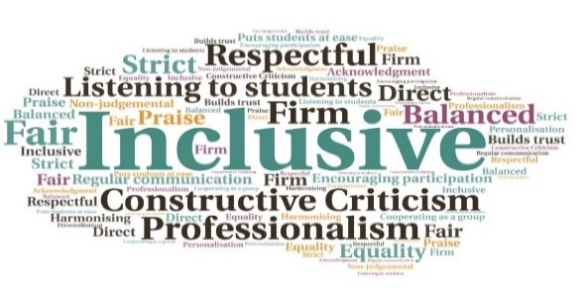  “…It was a very worthwhile day and of such value in getting to know our colleagues better.”  “This was an excellent networking day. The check in where everyone brought an object of significance allowed us to get to know each other a bit better. The break-out sessions were useful in terms of reflecting on our experiences and again gave us the opportunity to network with other counsellors across the partnership.”  “Working outside my comfort zone which always leads to my empathy when working with clients. And in this case I have explored with my line manager the option of purchasing some materials... Networking with likeminded people was beneficial to my sense of wellbeing”  Offers CPD opportunities which staff may otherwise struggle to access | Ensures counsellors are up to date with the latest guidance and legislation | Access to expert speakers | Opportunities to share best practice | Provides chance for networking for staff from across the partnership  Counselling Network CPD Events  Executive Office  W | Goal: To provide much needed CPD for staff, which means students reap the benefits of being able to access well informed and knowledgeable support across the partnership.  Submitted by: Allie Scott  Project: To support academic partners to enable their counsellors to reach the minimum level of CPD hours needed. Provision of in-house opportunities allowed events to be used in a multifunctional manner.  Benefit to: Counselling staff across the partnership.  Key message: Improve core skills and support staff CPD  Ensure practitioner’s skills and knowledge remain up to date  Allow staff to learn more about their discipline, including adherence to legislative requirements  Keep staff informed of ever-changing sector guidance  Help part-time staff to complete necessary CPD at times to suit them  Provide an opportunity for staff to share best practice and facilitate discussion  Project delivery  Annual development day, bringing counsellors together from across the partnership  A second CPD event is also held and open to wellbeing staff, inclusive practitioners, support staff, and HISA  Links with external groups give access to speakers, many of whom are experts in their field  Impact: The events have been beneficial to practitioners but there has also been a ‘ripple effect’ impacting positively across student services teams, increasing the ability of staff to understand and support students presenting with some of the complex needs covered during these sessions.

