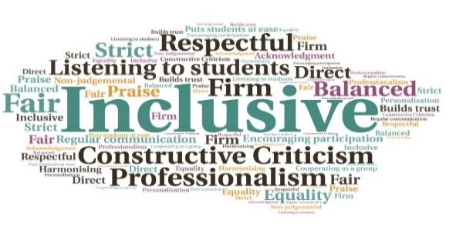  Supports students through intricate administrative processes| Available to all students, wherever they are based | Net Promoter Score (NPS) reported a score of 10, indicating high praise and a strong willingness to recommend to others | Over 30 cases of appeals, complaints, and misconduct were dealt with | Over 60 hours was invested meeting with students and addressing their challenges  HISA Advice Service  HISA  W | Goal: To enhance the student experience by offering assistance, expertise, and support on a wide range of topics.  Submitted by: Elena Semple  Project: To set up a service which helps students work towards resolving concerns and advocates for their rights, while respecting impartiality and confidentiality in the process.  Benefit to: All UHI students, from FE to Postgrad.  Key message: Guide students through advocacy  Enhance student wellbeing by empowering them to make informed decisions  Develop clear and concise content on key themes, issues, and challenges  Provides individualised support and guidance  Can be accessed remotely, via email, telephone, and video calls  Collaboration with UHI and HISA officers ensures a customised service to meet the specific needs of students studying in the Highlands and Islands  Project delivery  The Advice Service is run by a highly trained member of HISA with a law background  The Service responds to member’s requests for advice, providing helpful information and signposting to appropriate resources  It also offers casework support and advocacy  The Service covers areas such as academic misconduct, complaints, and appeals  Access to the Service effectively eliminates obstacles to seeking help and fosters a safe, supportive environment  Impact: The ready availability of the Service has proven advantageous, with more than 50 cases successfully resolved since April 2022. The Service provides a centralised resource for guidance, and has also contributed to improving transparency, fairness, and accountability within UHI processes.

