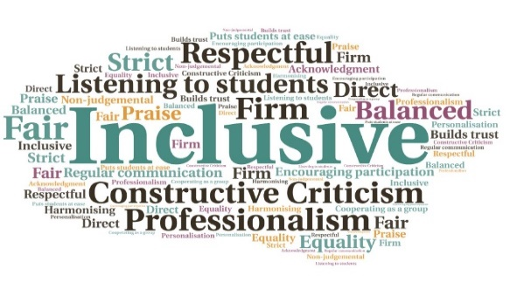  Students are informed and engaged to help support their student journey | Collaborative approach between UHI and HISA| Raised the profile of UHI Careers | Reduced stress at essay deadline time| Improved engagement with networked students |  “The students enjoyed the session immensely and - especially the way which Iain and Emma worked to engage different learning styles was appreciated (the team points exercise, use of PowerPoint, short activities) and the conversation around time hoovers was taken to heart, as people pledged afterwards to use social media less as this is a huge distraction. The section on BUZZ personality testing has also made our students more aware that others deal with stress in different ways, which in a small and close knit college is very important.”  Self-development Workshops for Students  Executive Office UHI/HISA  W | Goal: Deliver tailored workshops for students to help them develop a whole range of skills and attributes that are highly valued by employers.  Submitted by: Iain Eisner (Executive Office UHI) and Emma Robson (HISA)  Project: Collaboration between the UHI Careers and Employability Team and HISA to reach students and respond to specific support requests by creating and delivering tailored workshops.  Benefit to: All students  Key message: Develop skills for successful learning and future  employment  Promote the idea that many skills are developed through student association activity.  Encourage students to consider time management as a critical attribute for successful learning and future employment.  Support students during busy periods by helping them set priorities and apply beneficial strategies.  Create an environment where students learn in an informal and engaging way but with a serious outcome.  Deliver workshops with plenty of activities, discussion, and reflection.  Project delivery  Workshop content developed by the Careers Team. Delivery of different parts of the workshops split between UHI staff and HISA.  Workshops delivered in conjunction with additional activity, to improve cost effectiveness.  Demand identified through discussions with HISA colleagues across the partnership.  Students were able to articulate the kind of support they required and workshops were tailored to meet that demand.  The workshops improved student relationships with the Careers Team.  Impact: The workshops are transferrable across the whole of the partnership, and can be delivered at any campus or learning centre. To discuss how this initiative could be beneficial to your community please contact Iain Eisner

