Student Support Initiative

Project Outline

Perth College Student Support Team launched The Student Support Hub in February 2017 during the Health Happy You health week. The hub is a vibrant welcoming space which can be utilised by any student requiring wellbeing support or advice. This hub is a reconfiguration of existing open plan space within the previous employability centre which was under utilised and has been transformed at minimal cost into an area which enables easy access to self help wellbeing materials and facilitates delivery of a range of support methodology such as wellbeing workshops and events and daily drop in support sessions.
The hub makes it possible for students with any wellbeing support need to access a safe space within the busy college environment when required and not necessarily require immediate access to a member of staff.

This new area provides a supportive space for students as well as providing opportunity to deliver a triage system of support with first point of access to the support service available through the daily drop in service based here. Students can also access and self refer to counselling, face to face wellbeing support and self help materials as well as use the space for other additional support needs. Since it’s inception it has enabled the support staff to deliver programmed wellbeing workshops, counselling drop in cafes, information events and also enable students with additional support needs or emotional support needs the opportunity for a safe space when required e.g for students experiencing panic attacks or for students with a social communication condition who feel anxious during unstructured break times.

The space although small is multipurpose and functional and has been utilised daily by individuals, groups and staff to access support services with a reported increase of access of drop in sessions of 90% in it’s first week in comparison with the same time of year last academic session. Outwith drop in support times, students can still access support in the form of self help materials or use the space as a support measure if appropriate with support staff based in nearby areas.

Project Delivery
Feedback from previous academic sessions from both students and staff highlighted that improvement was required in delivery of support services and methods of accessing support . Increasing numbers of students requesting support and increasing complexities of support needs required creative solutions within limited resources. The support team were fragmented across campus and drop in sessions varied in location and times to try to meet demand however this meant confusion existed on how to access services at certain times. Transitional support staff were sometimes unable to introduce students to supports available as timetabling not always conducive to introduction to individual staff and crisis support provided in various locations.
Verbal feedback from students accessing student support, discussion with various curriculum areas and consultation with external agencies referring to student support services highlighted need for support hub with strong visual presence and regular location which could be multi purpose but easily identifiable to those students who required wellbeing support.
Requests for additional resources were limited due to funding constraints so creative use of existing resources and space were suggested following team consultation and the new support hub was launched within a short time frame and with minimal expenditure. The hub was launched during the Health Happy You event in February 2017 which enabled a variety of activities and information events to be offered to students which were previously not available such as exam stress & resilience workshops, counselling café drop in sessions and access to extensive self help materials in paper format and online.

The support hub has also afforded the opportunity for creative support solutions to be identified for individual students who may require more intensive support. For example utilizing the space as a safe zone for students with extreme anxiety who otherwise may have left the college premises. The space is used as a stepping stone to develop confidence in attending college on days when anxiety is proving to be problematic and assisting students to develop resilience in this area.

The project is early in it’s inception but feedback from both students and staff has been very positive and participation and engagement across the student body has been hugely encouraging.

Outcome

The new support hub has only been in operation for 2 months but has already seen a 90% increase in the number of students accessing the daily support drop in sessions (comparative figures with 15/16 academic session). This highlights the effectiveness of it’s visual presence and enables students to access timeous support and ensure their support needs can be assessed using a triage system to ensure they receive targeted support which meets their support need as far as possible and avoids duplication or confusion in service delivery.

The feedback from events and workshops delivered so far has been excellent and student engagement and participation in student support services has increased since the hubs inception. The initiative is in it’s infancy but all feedback from evaluations has been positive with 100% of workshop participants stating they would recommend to a friend and that they found it “extremely useful” or “useful”

Individual support plans and behaviour support plans are now able to identify the support hub space as an addition to existing support measures which assists some students to develop skills in managing their anxiety or health condition in a busy learning environment.

External organisations are also able to access the space to offer advice or drop ins to students and this is an area we hope to continue to develop over the next year. Student association groups can also access the space to assist to build interest in new groups or societies. Recent contact with local Warhammer organisation resulted in much interest and new group will be established initially engaging with students from the support hub.

Transitions Officer has been able to introduce students with enhanced support needs to the support hub at an early stage and explain how to access services and the space during their transitional support phase as have external support agencies such as Social Work Services, Skills Development Scotland, Autism Initiatives and local voluntary care providers.

Plans for the future development of the hub will be confirmed following further consultation with students at the end of the Semester and plans to link in with PDP sessions in some sector areas will enhance joint working partnerships to ensure effective support service meets demands and support needs of students as far as possible.

Evidence of activity during the Health Happy You Event delivered via the Student Support Hub is detailed below.

Healthy Happy You Highlights 2017
Student Support team at Perth College UHI

Getting connected
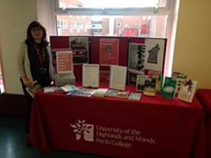
RASAC, Cedar Project: Perthshire Women’s Aid, PND and Me, Young Fathers Network, Fearless and Warhammer were on campus.

Warhammer proved to be very successful and several students have shown interest in a college group. A group is going to be set up for students on campus.

Maria had a selection of books used by the Library Book Club and was looking for students to sign up to participate in the club. She also brought some information along in connection to Spanish classes.

Counselling café and drop-in

We ran a counselling café inviting students to come along to find out more about counselling. We gave away free travel mugs to all those who attended. 14 students attended.

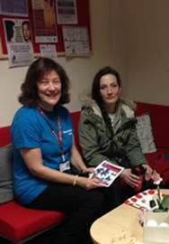

We ran counselling drop-in inviting students to come along for a relaxed and friendly information session in the student support hub. We gave away free travel mugs to those who come in.

New Skills Class 2 kindly baked a tray of Oreo cookie brownies and brought them to the hub for our drop-in.

Time for you!

The hairdressing department offered a blow dry and conditioning treatment for £1 and 12 students made appointments and went along to these. The beauty department offered a mini facial, file and polish or a neck, back and shoulder massage for £3, unfortunately no one went along to the beauty appointments.

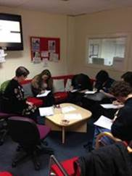

The Student Support Hub

We ran the 5 Ways to Wellbeing event from inside the hub. These included ‘Take Notice, Connect, Keep Learning, Be Active and Give’.

Exam Stress and Resiliency workshops were delivered by Alex Weir and Vanessa Robb, Wellbeing and Support Officers, 6 students attended the Exam Stress workshop and 7 students attended the Resiliency workshop.

Free fruit!

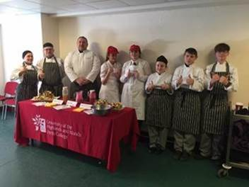

Free fruit smoothies and fruit kebabs were prepared and served by Hospitality Bronze students and school pupils in the library corridor.

Health and Fitness

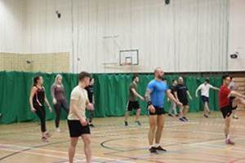
A free fitness taster class was run by the HND Fitness Health and Exercise students, 36 students and staff attended this.

Fitness health checks were delivered by the Sports and Fitness students. 40 students and staff went along to get a health check carried out.

Free gym sessions throughout the fortnight and 13 students went along to try out the gym.

Outdoor Sport and Fitness students set up a slackline, this is a piece of polyester webbing which is used to balance on and walk along. 2 students went along to try this out.
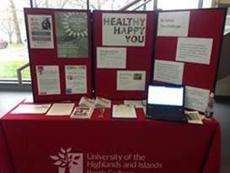
The Nursery children had great fun participating in a mini workout to encourage them to keep active.

During the fortnight one of the themes was ‘Be Active’. Each individual UHI partner had a target of 773 miles of activities and exercises to aim to. During the fortnight Perth College UHI students and staff have managed to accrue 13,946 miles and 33,841 minutes.

HIV and STI testing was offered by the Terrence Higgins Trust. This was set up in the Academy of Sport and Wellbeing. Several students went along for information and 10 students were officially tested.

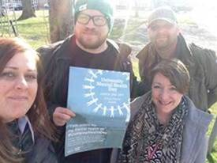

University Mental Health Day

On University Mental Health Day staff and students participated in a mile walk in the surrounding area to promote good health and the importance of talking with someone if you are experiencing low mood.

And the prizes go to…

Everyone who participated in any of our events, walks, activities and competitions has been entered into a free prize draw with prizes including 5 Zumba classes, 2 health suite vouchers for Live Active Leisure and a Gallery restaurant voucher for 2 for lunch.
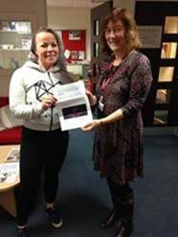
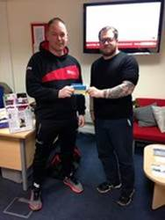
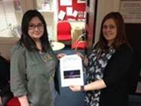

During the fortnight we ran a poetry competition asking students to write about what makes them healthy and happy. We received 2 entries for the competition and a winner will be chosen by Emma Hamilton, Communications Lecturer in due course.

